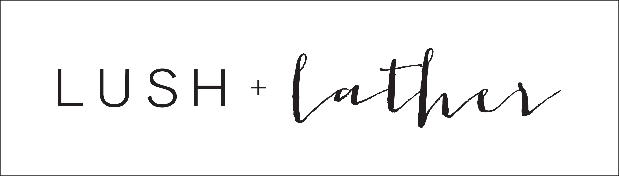

Agreement for Beauty services performed by Kelli Stephenson of Lush + Lather
It is hereby agreed by and between (Kelli Stephenson), hereinafter referred to as “artist”, and, referred to as “purchaser”, as follows:

Event Date and Time:
Purchaser hereby requests and agrees to retain the Artist to appear and perform as specified below. Date (hereinafter referred to as “Event Date”)
Ceremony Start Time
First Look Time
Bridal Party Ready Time
Address (for getting ready)
City
State
Photographer

Bridal Services
Additional Services
Date for Bridal Trial

Cost of Services and travel fee:
Purchaser agrees to the cost of $ /total sum of services.
Purchaser agrees to pay travel fee of $ for travel to
(city)

Deposit:
Purchaser agrees to pay a $150 non-refundable deposit. A deposit of $150 shall be made payable upon execution of this agreement. Said sum shall constitute a non-refundable deposit. Artist shall have the option to void agreement if deposit and signed agreement is not received within 15 days of receiving this contract. The balance of the total sum is due 7 days prior to event date, in the form of a debit or credit card. In the event that the Artist receives written notice from the Purchaser a minimum of 60 days prior to the event date that the Artist’s services will not be required by Purchaser then Purchaser shall only be liable for the $150 non-refundable deposit. In the event that the artist receives written notice from the Purchaser, notifying the Artist of cancellation within 60 days to the event date, purchaser agrees to pay fifty percent of the contracted price. If the purchaser shall fail to notify the Artist of cancellation in the manner as provided above, or in the event of breach of this agreement, then the purchaser shall remain responsible for the full contract price specified, including all costs expense, damages, and fees, (including costs of cancellations, court costs, and reasonable attorney’s fees) incurred by Artist in enforcing this agreement.

Damaged or stolen goods
Purchaser agrees to indemnify artist for any loss or damage to the artist, it’s personnel, and equipment at the event site, provided the loss or damage was by person or persons other than the artist or assistant.

Emergency policy for the artist:

The artist shall not be liable for omissions or failure to perform its obligation, if an accident occurs, or there are events that reasonably may be deemed beyond control of the artist (i.e. severe sickness, accident, weather, road closures, etc.) If the artist should be materially or physically incapacitated from performing its service for any reason Artist agrees to refund the purchases deposit in full.

Events on holidays or outside of business hours:
Purchaser acknowledges that events or work being performed either outside of normal business hours (8am-6pm), and/or work being performed on a holiday, may be subject to an additional fee.

Allergic Reactions:
The artist makes no warranties and shall not be liable for any direct and consequential damages arising out of the performance of service under this agreement (i.e. allergic reactions, rash, hives, sensitivities, etc.)

Denying Services:
Artist reserves the right to deny services to any person or persons requesting services that may have concerning/contagious skin or health conditions. Please note that even if the individual thinks it is nothing that is contagious it is ultimately up to the artist.

Adding on:
Those persons who are included in this contract are guaranteed services as long as individuals are on time. If mutually agreed to, additional clients may be added before the event date for service charges listed on price sheet. If an individual who did not sign up for services before the day of the event but would like to be added the day of the event, it is up to the artist’s discretion and there will be an additional fee of $15 on top of the cost of the service charge reflected on the price sheet.

Tardiness:
If the purchaser is tardy and is not present within 30 minutes of start time there is an additional fee of $20 for every 30 minutes that the individual is tardy. It is extremely important that both you and anyone receiving services is on time so that we stay on schedule and have the party feeling relaxed and calm throughout the experience. If anyone is extremely tardy (greater than 45 minutes), please note that they may not be able to still receive the service.

Credit Card Information:
Your credit/debit card will be kept on file to be used to charge both your deposit, as well as give you the option to have the remainder of your balance charged.. A 20% gratuity charge will be figured into the final sum. Said sum will be due 7 days prior to the Event Date, and will be charged to the card on file, unless other arrangements are made between Purchaser and Artist.

Credit Card Number:

Expiration

CVV # (3 or 4 digit code on back of card)
Billing Zip Code

Name as it Appears on Card:
Signature:

Thank you for choosing Lush + Lather to share in your special day.

Warmest Regards,
Kelli Stephenson

Purchaser: (sign) Date:

Artist: (sign) Date:

Please sign above and return contract to Artist. When completed contract is received, Artist will charge $150 to card on file. This will serve as your, (purchasers) non-refundable deposit.
Remaining balance: $ (after deposit)

Important Information for your Bridal Service

To help me serve you better and ensure that your wedding day runs smoothly, we ask that you and your wedding please follow these simple guidelines:

- Please arrive with semi-clean, dry hair to help the hold of your hairstyle. An additional fee may apply if you request a wash and blow dry or straightening.
- Bring pictures of at least 3-5 different hairstyles that you are interested in for you and the hair stylist to consider.
- Please bring in your headpiece, veil, and any hair accessories to try on
- On the day of your wedding, please wear a loose shirt, like a collar-less button-up or v-neck that will not conflict with your set style.
- Most importantly, please be on time for your wedding day appointment. Even starting 15 minutes late will put everyone behind and we don’t want you to be late for your special day!

